实验报告
2019 年 5 月 9 日 成绩：
姓名 |  | 学号 |  | 班级
专业 | 计算机科学与技术 |  | 课程名称 | 计算机组成原理课程设计
任课老师 | 章复嘉 | 指导老师 | 章复嘉 | 机位号
实验序号 | 实验四 | 实验名称 | 寄存器堆设计实验
实验时间 | 2019.5.9 | 实验地点 | 1-225 | 实验设备号
一、实验目的和实验要求
学习使用Verilog HDL语言进行时序电路的设计方法；
掌握灵活运用Verilog HDL语言进行各种描述与建模的技巧和方法；
学习寄存器堆的数据传送与读写工作原理，掌握寄存器堆的设计方法。
二、实验程序源代码
寄存器模块
`timescale 1ns / 1ps
module REG(Clk,Reset,Write_Reg,W_Data,R_Addr_A,R_Addr_B,W_Addr,R_Data_A,R_Data_B);
input Clk,Reset;//时钟，复位
input Write_Reg;//写入信号
input [4:0]R_Addr_A;//寄存器号
input [4:0]R_Addr_B; //寄存器号
input [4:0]W_Addr;//寄存器号
input [31:0]W_Data;//写入数据
output [31:0]R_Data_A;//A数据口
output [31:0]R_Data_B;//B数据口
integer i; //想到于int i,用于初始化数组
reg [31:0] REG_Files[0:31];
always @(posedge Clk or posedge Reset)
begin
if(Reset) //高电平有效，=1则初始化
begin
for(i=0;i<32;i=i+1)begin
REG_Files[i] = 0;//初始化32个寄存器
end
end
else
begin
REG_Files[0] = 32'hFFFF_1111;
if (Write_Reg&&W_Addr>0)
REG_Files[W_Addr] = W_Data;//写入寄存器;
end
end
assign R_Data_A = REG_Files[R_Addr_A];
assign R_Data_B = REG_Files[R_Addr_B];

endmodule

顶层代码
`timescale 1ns / 1ps
module Top_REG(sw,swb,clk,led,which,seg,enable);
input [1:32] sw;
input [6:1] swb;
input clk; // 数码管相关
output [2:0] which;
output [7:0] seg;
output reg enable = 1; // 默认开启数码管使能
output reg [1:32]led;
wire [31:0]R_Data_A,R_Data_B;
reg [31:0]W_Data;
reg [4:0]R_Addr_A,R_Addr_B,W_Addr;
/*swb[5]模拟时钟，swb[1]清零，swb[2]写信号*/
REG reg1(swb[5],swb[1],swb[2],W_Data,R_Addr_A,R_Addr_B,W_Addr,R_Data_A,R_Data_B);

Display Display_Instance(.clk(clk), .data(R_Data_B),
.which(which), .seg(seg));
always@(*)
begin
W_Addr = 0;
W_Data=0;
if(!swb[2])// 读操作
begin
R_Addr_A = sw[1:5];
R_Addr_B = sw[6:10];
led = R_Data_A;
end
else// 写操作
begin
W_Addr = sw[11:15];
if(swb[4])begin
W_Data = sw[1:32];
led = W_Data;
end
end
end
endmodule
三、仿真文件和波形图（有就填，没有就不填）
`timescale 1ns / 1ps

module REGtest();
reg Clk, Reset, Write_Reg;
reg [4:0] R_Addr_A ,R_Addr_B, W_Addr;
reg [31:0] W_Data;
wire [31:0] R_Data_A, R_Data_B;
initial
begin
Reset=0;//不清零
Write_Reg=1;//写入

R_Addr_A=5'b00000;//A端口读寄存器0
W_Data=32'h7fff_fff0;W_Addr=5'b00000;Clk=0;#50;Clk=1;#50;//将32'h7fff_fff0写入寄存器0

R_Addr_A=5'b00001;//A端口读寄存器1
W_Data=32'h7fff_fff1;W_Addr=5'b00001;Clk=0;#50;Clk=1;#50;//将32'h7fff_fff1写入寄存器1

R_Addr_A=5'b00010;//A端口读寄存器2
W_Data=32'h7fff_fff2;W_Addr=5'b00010;Clk=0;#50;Clk=1;#50;//将32'h7fff_fff2写入寄存器2

R_Addr_A=5'b00011;//A端口读寄存器3
W_Data=32'h7fff_fff3;W_Addr=5'b00011;Clk=0;#50;Clk=1;#50;//将32'h7fff_fff3写入寄存器3

R_Addr_B=5'b00100;//B端口读寄存器4
W_Data=32'h7fff_fff4;W_Addr=5'b00100;Clk=0;#50;Clk=1;#50;//将32'h7fff_fff4写入寄存器4

R_Addr_B=5'b00101;//B端口读寄存器5
W_Data=32'h7fff_fff5;W_Addr=5'b00101;Clk=0;#50;Clk=1;#50;//将32'h7fff_fff5写入寄存器5

R_Addr_B=5'b00110;//B端口读寄存器6
W_Data=32'h7fff_fff6;W_Addr=5'b00110;Clk=0;#50;Clk=1;#50;//将32'h7fff_fff6写入寄存器6

R_Addr_B=5'b00111;//B端口读寄存器7
W_Data=32'h7fff_fff7;W_Addr=5'b00111;Clk=0;#50;Clk=1;#50;//将32'h7fff_fff7写入寄存器7
end
//实例化寄存器堆模块
REG test(Clk,Reset,Write_Reg,W_Data,R_Addr_A,R_Addr_B,W_Addr,R_Data_A,R_Data_B);
endmodule

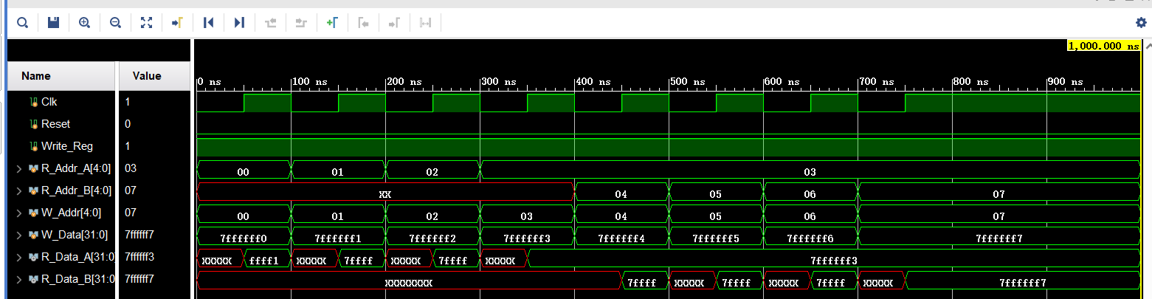
四、电路图（有就填，没有就不填）
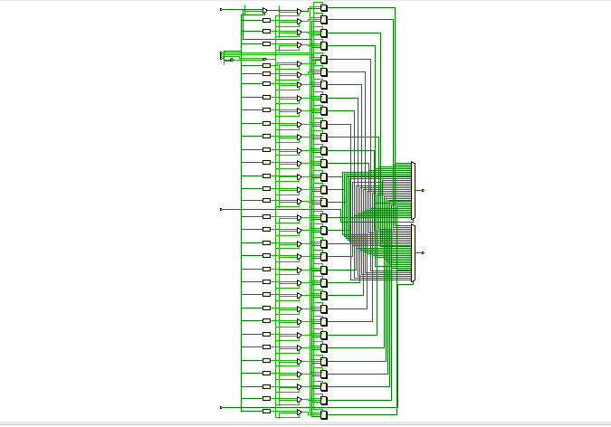
五、引脚配置（约束文件，有就填，没有就不填））
# 开启比特流压缩，优化 .bit 文件大小
set_property BITSTREAM.GENERAL.COMPRESS TRUE [current_design]

# Switch，开关
set_property PULLDOWN true [get_ports sw]
set_property IOSTANDARD LVCMOS18 [get_ports sw]
set_property PACKAGE_PIN T3 [get_ports {sw[1]}]
set_property PACKAGE_PIN U3 [get_ports {sw[2]}]
set_property PACKAGE_PIN T4 [get_ports {sw[3]}]
set_property PACKAGE_PIN V3 [get_ports {sw[4]}]
set_property PACKAGE_PIN V4 [get_ports {sw[5]}]
set_property PACKAGE_PIN W4 [get_ports {sw[6]}]
set_property PACKAGE_PIN Y4 [get_ports {sw[7]}]
set_property PACKAGE_PIN Y6 [get_ports {sw[8]}]
set_property PACKAGE_PIN W7 [get_ports {sw[9]}]
set_property PACKAGE_PIN Y8 [get_ports {sw[10]}]
set_property PACKAGE_PIN Y7 [get_ports {sw[11]}]
set_property PACKAGE_PIN T1 [get_ports {sw[12]}]
set_property PACKAGE_PIN U1 [get_ports {sw[13]}]
set_property PACKAGE_PIN U2 [get_ports {sw[14]}]
set_property PACKAGE_PIN W1 [get_ports {sw[15]}]
set_property PACKAGE_PIN W2 [get_ports {sw[16]}]
set_property PACKAGE_PIN Y1 [get_ports {sw[17]}]
set_property PACKAGE_PIN AA1 [get_ports {sw[18]}]
set_property PACKAGE_PIN V2 [get_ports {sw[19]}]
set_property PACKAGE_PIN Y2 [get_ports {sw[20]}]
set_property PACKAGE_PIN AB1 [get_ports {sw[21]}]
set_property PACKAGE_PIN AB2 [get_ports {sw[22]}]
set_property PACKAGE_PIN AB3 [get_ports {sw[23]}]
set_property PACKAGE_PIN AB5 [get_ports {sw[24]}]
set_property PACKAGE_PIN AA6 [get_ports {sw[25]}]
set_property PACKAGE_PIN R2 [get_ports {sw[26]}]
set_property PACKAGE_PIN R3 [get_ports {sw[27]}]
set_property PACKAGE_PIN T6 [get_ports {sw[28]}]
set_property PACKAGE_PIN R6 [get_ports {sw[29]}]
set_property PACKAGE_PIN U7 [get_ports {sw[30]}]
set_property PACKAGE_PIN AB7 [get_ports {sw[31]}]
set_property PACKAGE_PIN AB8 [get_ports {sw[32]}]

# Switch Button，按钮
set_property IOSTANDARD LVCMOS18 [get_ports swb]
set_property PACKAGE_PIN R4 [get_ports {swb[1]}]
set_property PACKAGE_PIN AA4 [get_ports {swb[2]}]
set_property PACKAGE_PIN AB6 [get_ports {swb[3]}]
set_property PACKAGE_PIN T5 [get_ports {swb[4]}]
set_property PACKAGE_PIN V8 [get_ports {swb[5]}]
set_property PACKAGE_PIN AA8 [get_ports {swb[6]}]

# LED
set_property IOSTANDARD LVCMOS18 [get_ports led]
set_property PACKAGE_PIN R1 [get_ports {led[1]}]
set_property PACKAGE_PIN P2 [get_ports {led[2]}]
set_property PACKAGE_PIN P1 [get_ports {led[3]}]
set_property PACKAGE_PIN N2 [get_ports {led[4]}]
set_property PACKAGE_PIN M1 [get_ports {led[5]}]
set_property PACKAGE_PIN M2 [get_ports {led[6]}]
set_property PACKAGE_PIN L1 [get_ports {led[7]}]
set_property PACKAGE_PIN J2 [get_ports {led[8]}]
set_property PACKAGE_PIN G1 [get_ports {led[9]}]
set_property PACKAGE_PIN E1 [get_ports {led[10]}]
set_property PACKAGE_PIN D2 [get_ports {led[11]}]
set_property PACKAGE_PIN A1 [get_ports {led[12]}]
set_property PACKAGE_PIN L3 [get_ports {led[13]}]
set_property PACKAGE_PIN G3 [get_ports {led[14]}]
set_property PACKAGE_PIN K4 [get_ports {led[15]}]
set_property PACKAGE_PIN G4 [get_ports {led[16]}]
set_property PACKAGE_PIN K1 [get_ports {led[17]}]
set_property PACKAGE_PIN J1 [get_ports {led[18]}]
set_property PACKAGE_PIN H2 [get_ports {led[19]}]
set_property PACKAGE_PIN G2 [get_ports {led[20]}]
set_property PACKAGE_PIN F1 [get_ports {led[21]}]
set_property PACKAGE_PIN E2 [get_ports {led[22]}]
set_property PACKAGE_PIN D1 [get_ports {led[23]}]
set_property PACKAGE_PIN B1 [get_ports {led[24]}]
set_property PACKAGE_PIN B2 [get_ports {led[25]}]
set_property PACKAGE_PIN N3 [get_ports {led[26]}]
set_property PACKAGE_PIN M3 [get_ports {led[27]}]
set_property PACKAGE_PIN K3 [get_ports {led[28]}]
set_property PACKAGE_PIN H3 [get_ports {led[29]}]
set_property PACKAGE_PIN N4 [get_ports {led[30]}]
set_property PACKAGE_PIN L4 [get_ports {led[31]}]
set_property PACKAGE_PIN J4 [get_ports {led[32]}]

# 数码管相关
set_property IOSTANDARD LVCMOS18 [get_ports seg]
set_property PACKAGE_PIN H19 [get_ports {seg[7]}]
set_property PACKAGE_PIN G20 [get_ports {seg[6]}]
set_property PACKAGE_PIN J22 [get_ports {seg[5]}]
set_property PACKAGE_PIN K22 [get_ports {seg[4]}]
set_property PACKAGE_PIN K21 [get_ports {seg[3]}]
set_property PACKAGE_PIN H20 [get_ports {seg[2]}]
set_property PACKAGE_PIN H22 [get_ports {seg[1]}]
set_property PACKAGE_PIN J21 [get_ports {seg[0]}]
set_property IOSTANDARD LVCMOS18 [get_ports which]
set_property PACKAGE_PIN N22 [get_ports {which[0]}]
set_property PACKAGE_PIN M21 [get_ports {which[1]}]
set_property PACKAGE_PIN M22 [get_ports {which[2]}]
set_property -dict {IOSTANDARD LVCMOS18 PACKAGE_PIN L21} [get_ports enable]
set_property -dict {IOSTANDARD LVCMOS18 PACKAGE_PIN H4} [get_ports clk]

# [Place 30-574] Poor placement for routing between an IO pin and BUFG.If this
# sub optimal condition is acceptable for this design, you may use the
# CLOCK_DEDICATED_ROUTE constraint in the .xdc file to demote this message to a
# WARNING. However, the use of this override is highly discouraged.
set_property CLOCK_DEDICATED_ROUTE FALSE [get_nets clk_IBUF]
set_property CLOCK_DEDICATED_ROUTE FALSE [get_nets swb_IBUF[1]]
set_property CLOCK_DEDICATED_ROUTE FALSE [get_nets swb_IBUF[2]]
set_property CLOCK_DEDICATED_ROUTE FALSE [get_nets swb_IBUF[3]]
set_property CLOCK_DEDICATED_ROUTE FALSE [get_nets swb_IBUF[4]]
set_property CLOCK_DEDICATED_ROUTE FALSE [get_nets swb_IBUF[5]]
set_property CLOCK_DEDICATED_ROUTE FALSE [get_nets swb_IBUF[6]]
七、实验收获（心得体会等，请以个人为单位分别写）
扩展要求
实验代码
module REGALU(Clk,Reset,Write_Reg,ALU_OP,W_Data,R_Addr_A,R_Addr_B,W_Addr,R_Data_A,R_Data_B,R_Data_F,ZF,OF);
input Clk,Reset;//时钟，复位
input Write_Reg;//写入信号
input [3:0]ALU_OP;
input [4:0]R_Addr_A;//寄存器号
input [4:0]R_Addr_B; //寄存器号
input [4:0]W_Addr;//寄存器号
input [31:0]W_Data;//写入数据
//input [31:0]Input_Data;//外部输入数据
output [31:0]R_Data_A;//A数据口
output [31:0]R_Data_B;//B数据口
output [31:0]R_Data_F;//运算结果数据
output ZF;//结果为零标志ZF
output OF;//溢出标志位OF
wire [31:0]Data_C;//中间变量

//assign W_Data=Write_Select ? Input_Data : ALU_F;

REG reg_test(Clk,Reset,Write_Reg,W_Data,R_Addr_A,R_Addr_B,W_Addr,R_Data_A,R_Data_B);
ALU alu_test(ALU_OP,R_Data_A,R_Data_B,ZF,OF,Data_C);
assign R_Data_F = Data_C;
endmodule

仿真代码
`timescale 1ns / 1ps

module REGALUtest();
reg Clk, Reset, Write_Reg;
reg [4:0] R_Addr_A ,R_Addr_B, W_Addr;
reg [31:0] W_Data;
reg [3:0] ALU_OP;
wire [31:0] R_Data_A, R_Data_B,R_Data_C;
wire ZF,OF;
initial
begin
Reset=0;//不清零
Write_Reg=1;//写进去之后读读看

R_Addr_A=5'b00001;//A端口读寄存器1
R_Addr_B=5'b00010;//B端口读寄存器2
ALU_OP=4'b0000;//逻辑与
W_Data=32'h0000_0001;W_Addr=5'b00001;Clk=0;#25;Clk=1;#25;
W_Data=32'h0000_0010;W_Addr=5'b00010;Clk=0;#25;Clk=1;#25;

R_Addr_A=5'b00011;//A端口读寄存器3
R_Addr_B=5'b00100;//B端口读寄存器4
ALU_OP=4'b0001;//逻辑或
W_Data=32'h0000_1110;W_Addr=5'b00011;Clk=0;#25;Clk=1;#25;
W_Data=32'h0000_0011;W_Addr=5'b00100;Clk=0;#25;Clk=1;#25;

Write_Reg=0;//测试同时读出来
R_Addr_A=5'b00001;//A端口读寄存器1
R_Addr_B=5'b00010;#50//B端口读寄存器2

Write_Reg=1;//测试同时读出来
R_Addr_A=5'b00101;//A端口读寄存器5
R_Addr_B=5'b00110;//B端口读寄存器6
ALU_OP=4'b0010;//逻辑异或
W_Data=32'h0000_0000;W_Addr=5'b00101;Clk=0;#25;Clk=1;#25;
W_Data=32'h0000_0000;W_Addr=5'b00110;Clk=0;#25;Clk=1;#25;

R_Addr_A=5'b00111;//A端口读寄存器7
R_Addr_B=5'b00001;//B端口读寄存器1
ALU_OP=4'b0011;//逻辑或非
W_Data=32'h0000_1110;W_Addr=5'b00111;Clk=0;#25;Clk=1;#25;
W_Data=32'h0000_1110;W_Addr=5'b00001;Clk=0;#25;Clk=1;#25;

R_Addr_A=5'b00001;//A端口读寄存器1
R_Addr_B=5'b00010;//B端口读寄存器2
ALU_OP=4'b0100;//算数加
W_Data=32'h7fff_ffff;W_Addr=5'b00001;Clk=0;#25;Clk=1;#25;
W_Data=32'h7fff_fffd;W_Addr=5'b00010;Clk=0;#25;Clk=1;#25;

R_Addr_A=5'b00011;//A端口读寄存器3
R_Addr_B=5'b00100;//B端口读寄存器4
ALU_OP=4'b0101;//算数减
W_Data=32'h7fff_ffff;W_Addr=5'b00011;Clk=0;#25;Clk=1;#25;
W_Data=32'h7fff_fffd;W_Addr=5'b00100;Clk=0;#25;Clk=1;#25;

R_Addr_A=5'b00101;//A端口读寄存器5
R_Addr_B=5'b00110;//B端口读寄存器6
ALU_OP=4'b0110;//若A<B,则F=1，否则输出0
W_Data=32'h7fff_ffff;W_Addr=5'b00101;Clk=0;#25;Clk=1;#25;
W_Data=32'h7fff_fffd;W_Addr=5'b00110;Clk=0;#25;Clk=1;#25;

R_Addr_A=5'b00111;//A端口读寄存器7
R_Addr_B=5'b00001;//B端口读寄存器1
ALU_OP=4'b0111;//B逻辑左移A所指定的位数
W_Data=32'h0000_0001;W_Addr=5'b00111;Clk=0;#25;Clk=1;#25;
W_Data=32'h0000_0009;W_Addr=5'b00001;Clk=0;#25;Clk=1;#25;
end

//实例化寄存器堆模块
REGALU RA_Test(Clk,Reset,Write_Reg,ALU_OP,W_Data,R_Addr_A,R_Addr_B,W_Addr,R_Data_A,R_Data_B,R_Data_C,ZF,OF);
endmodule
仿真波形
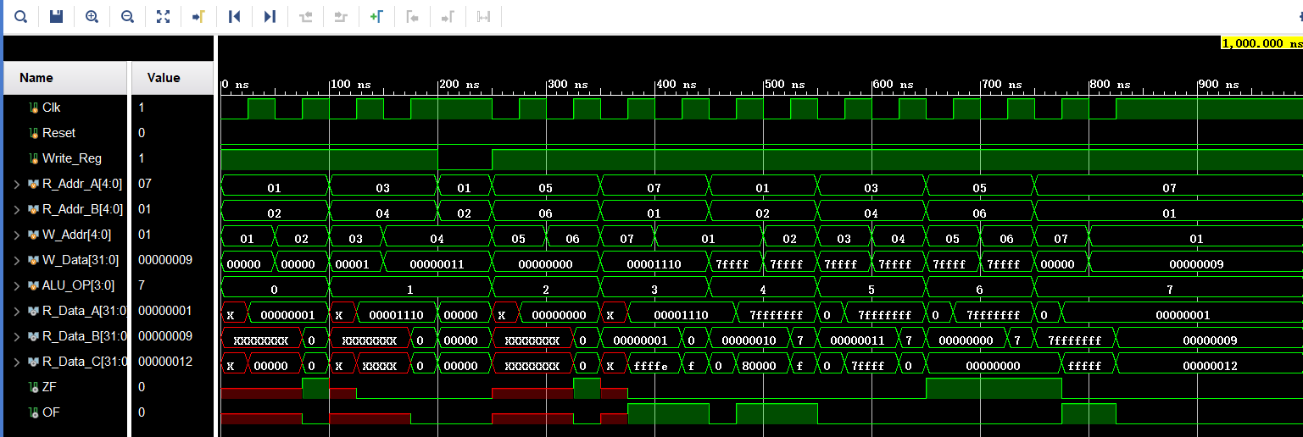
电路图

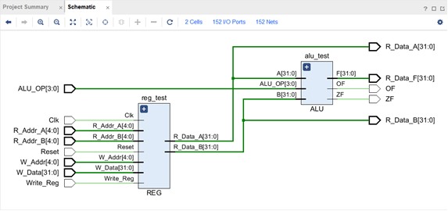
心得体会
- 仿真时要控制读写信号，是的两个端口同时读取能够体现
- 使用板子时，通过一个按钮设定时钟信号，数码管则使用系统clk，系统clk不能同时作为寄存器读写的时钟信号。开始程序时，先按下时钟按钮。
- 按钮按下为1，不按为0。
- Alu与寄存器共同使用时，采用调用模块，会使代码更清晰。
- 中间变量必须采用wire类型
- 模块调用不能写在always语句里

